1. **Which month has the highest sales? Is there any seasonality effect?**

**Answer:**

1. except for the year of 2014, November has the highest sales in all the years

Seasonality:

Definitely there is a seasonality effect, as you observe,

1. Every year there are lesser sales in Q1, notice that higher sales were in Q4.
2. There is a waving in sales during Q3 and a drop in October sales but the November and December sales have been raised up (I could see this raise in almost every year).
3. Feb month has the least sales and it is consistent in all the years.

Hence we can conclude there is seasonality effect based on data analysis.

Below are the supporting documents for questions

Sql Script:

*Select distinct to_number(M_number),Month,Year,sum(Sales),sum(Quantity) from*

*(Select Orderdate,To_Char(Orderdate,'Mm') M_number,*

*To_Char(Orderdate,'Month') Month,To_Char(Orderdate,'YYYY') Year , Sum(Sales) Sales,Sum(Quantity) Quantity*

*From SamplePageOrders*

*Group By Orderdate,To_Char(Orderdate,'mm'),*

*To_Char(Orderdate,'Month') ,To_Char(Orderdate,'YYYY')*

*Order By 1 Desc)*

*group by Month,Year,to_number(M_number)*

*order by 1,2,3;*

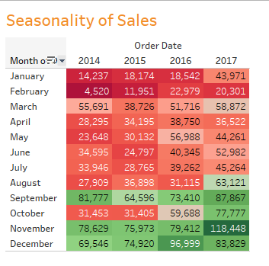

Please refer this Analysis Sheet for Reference



1. **Which product is the recent best seller?  
   Hint: There is no `right` answer for this question, please feel free to make your own interpretation and  
   give suggestion**

**Right now we don’t have any sufficient to identify the recent best Sellers information. However In Future, In Order to capture the seller information, we need include the seller information according to the sales Orders. Once we have seller’s information, we are in the position to identify the recent best sellers. Right now I have done with my own interpretation. Please find the below.**

**Sql Scripts:**

**Select To_Char(Orderdate,'YYYY'),**

**rank() OVER (partition by Sum(Sales) order by productname) rank,**

**productname,sum(sales) from SamplePageOrders**

**where upper(productname) like upper('%KI Adjustable-Height Table%')**

**group by To_Char(Orderdate,'YYYY'),productname**

**order by 2 ;**

**Screenshot:**

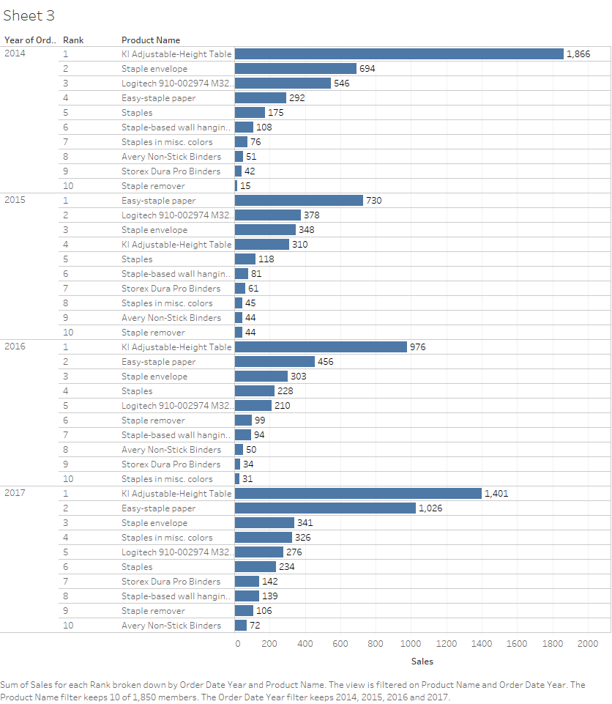

1. **Is there any group of products which are often bought together?  
   Hint: You can define you own metric, however, please explain the rationale behind**

**Answer**:

**This range of product is too huge to make such analysis. Probably this can be condensed by introduced using the ‘Product type’ dimension to make such analysis.**

1. **Is there any other insight you can get to help to improve sales number?  
   Hint: It is okay to not having any significant insight, but you have to state the hypothesis and verify**

**Group A:**

How many of the Products sold in 2014 are not sold in the consequent years = 40

**Group B:**

How many of the Products introduced 2014 after are not successful in 2017 – 114

**Insights:**

It is very important that can remove the products those belong to Group A from inventory

There are almost 119 products introduced after 2014 which has sale in 2015,16 but there are no sales in 2017.The reason should be investigated and if there are no sales, these products should be removed from inventory.

**5. Based on the data we have, what kind of BI dashboards you would build in order to help the sales  
team monitoring the performance?**

Dashboards:

1. Using Metrics Sales/Quantity – We can derive products that are more yielding for the year basis
2. Top 10 products bought in Quantity – To Maintain inventory List
3. Top 10 products in Sales – To conduct a strategy on discounts.
4. If the Order ID first letters refers the country then in the case , we can make the

“Sales by Country Report”.

1. Sales by Product/Year/Customer